VISVESVARAYA TECHNOLOGICAL UNIVERSITY
“JnanaSangama”, Belgaum -590014, Karnataka.


LAB REPORT

on

Object Oriented Java Programming (23CS3PCOOJ)

Submitted by
Rudra Singh (1BF24CS257)

in partial fulfillment for the award of the degree of
BACHELOR OF ENGINEERING
in

Computer Science And Engineering

B.M.S. COLLEGE OF ENGINEERING
(Autonomous Institution under VTU)

BENGALURU-560019

Aug-2025 to Jan-2026

B.M.S. College of Engineering,
Bull Temple Road, Bangalore 560019
(Affiliated To Visvesvaraya Technological University, Belgaum)
Department of Computer Science and Engineering


CERTIFICATE

This is to certify that the Lab work entitled “Object Oriented Java Programming (23CS3PCOOJ)” carried out by Rudra Singh(1BF24CS257), who is bonafide student of B.M.S. College of Engineering. It is in partial fulfilment for the award of Bachelor of Engineering in Computer Science and Engineering of the Visvesvaraya Technological University, Belgaum. The Lab report has been approved as it satisfies the academic requirements in respect of an Object-Oriented Java Programming (23CS3PCOOJ) work prescribed for the said degree.

Dr. Kavitha Sooda Professor & HOD
Department of CSE, BMSCE
Dr. Seema Patil
Associate Professor Department of CSE, BMSCE

Index
Sl.  No. | Date | Experiment Title | Page No.
1 | 23-09-25 | Implementing Quadratic Equation | 4-6
2 | 14-10-25 | Calculating SGPA of a Student | 7-12
3 | 14-10-25 | Using the toString() Method | 13-17
4 | 4-11-25 | Using Abstract Class | 18-21
5 | 11-11-25 | Implementing Inheritance | 22-31
6 | 18-11-25 | Using Packages | 32-36
7 | 25-11-25 | Implementing User Defined Exceptions | 37-40
8 | 9-12-25 | Multi-threading | 41-42

Github Link:
https://github.com/RudRaS1ngh/Java

Program 1
Implement Quadratic Equation
Code:
import java.util.Scanner;
class quadratic{
public static void main(String args[]){
int a,b,c;
double d,r1,r2;
Scanner scnr=new Scanner(System.in);
System.out.println("Enter the value of 'a' (in ax^2 + bx +c=0):");
a=scnr.nextInt();
if(a==0){
System.out.println("Not a quadratic equation.");
}
else{
System.out.println("Enter the value of 'b' (in ax^2 + bx +c=0):");
b=scnr.nextInt();
System.out.println("Enter the value of 'c' (in ax^2 + bx +c=0):");
c=scnr.nextInt();
d=(b*b)-4*a*c;
if(d==0){
System.out.println("Roots are real and equal.");
r1=(-b)/(2*a);
System.out.println("Value of both roots:");
System.out.println(r1);
}
else if(d>0){
System.out.println("Roots are real and unequal.");
r1=((-b)-Math.sqrt(d))/(double)(2*a);
r2=((-b)+Math.sqrt(d))/(double)(2*a);
System.out.println("Value of root1:");
System.out.println(r1);
System.out.println("Value of root2:");
System.out.println(r2);
}
else{
System.out.println("Roots are imaginary.");
r1=(-b)/(2*a);
r2=Math.sqrt(-d)/2*a;
System.out.println("Value of root1:");
System.out.println(r1);
System.out.println("Value of root2:");
System.out.println(r2);
}
}
}
}

Output:
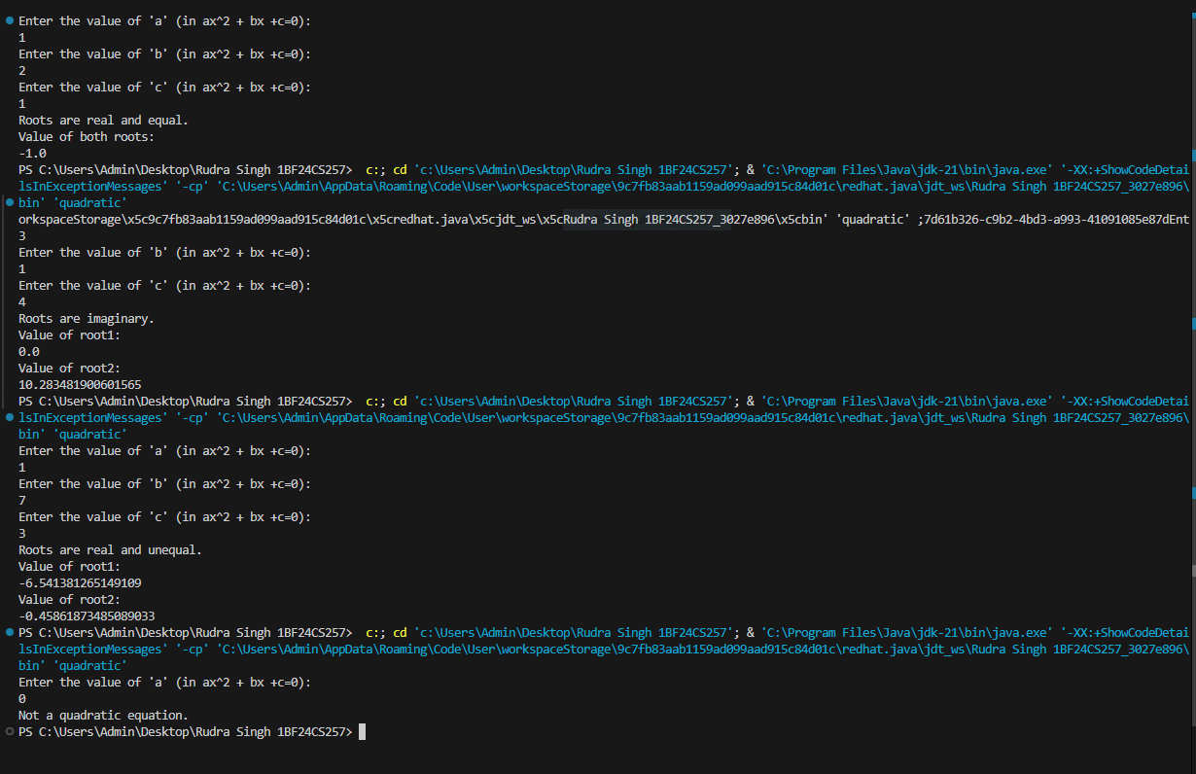

Program 2
Calculating SGPA of a student
Code:
import java.util.Scanner;
class Student{
int i;
int subjectmarks[]=new int[10];
int credits[]=new int[10];
int grade[]=new int[10];
String name;
String usn;
Scanner scnr=new Scanner(System.in);
Student(String n,String u){
name=n;
usn=u;
}
void getmarks(){
for(i=0;i<7;i++){
int a;
int j=i+1;
System.out.println("Enter marks for subject "+j+":");
a=scnr.nextInt();
subjectmarks[i]=a;
System.out.println("Enter credits for subject "+j+":");
credits[i]=scnr.nextInt();
}
for(i=0;i<7;i++){
grade[i]=(subjectmarks[i]/10)+1;
}

}
int effectivescore(){
int efscore=0;
for(i=0;i<7;i++){
efscore+=grade[i]*credits[i];
}
return efscore;
}
int totalcredits(){
int creds=0;
for(i=0;i<7;i++){
creds+=credits[i];
}
return creds;
}
double sgpa(){
double sg_pa=(double)effectivescore()/(double)totalcredits();
return sg_pa;
}

}

class Stud{
public static void main(String args[]){
Student s1[]=new Student[5];
int i;
String nm;
String us;
int j=0;
int a;
for(i=0;i<2;i++){
Scanner scnr1=new Scanner(System.in);
int k;
k=i+1;
System.out.println("");
System.out.println("Enter name of student"+k+":");
nm=scnr1.nextLine();
System.out.println("Enter USN of student:");
us=scnr1.nextLine();
s1[i]=new Student(nm,us);
s1[i].getmarks();
j++;
}
for(i=0;i<j;i++){
System.out.println("Name:"+s1[i].name);
System.out.println("USN:"+s1[i].usn);
System.out.println("Effective Score:"+s1[i].effectivescore());
System.out.println("Total Credits:"+s1[i].totalcredits());
System.out.println("SGPA:"+s1[i].sgpa());
System.out.println("");
}
}
}

Output: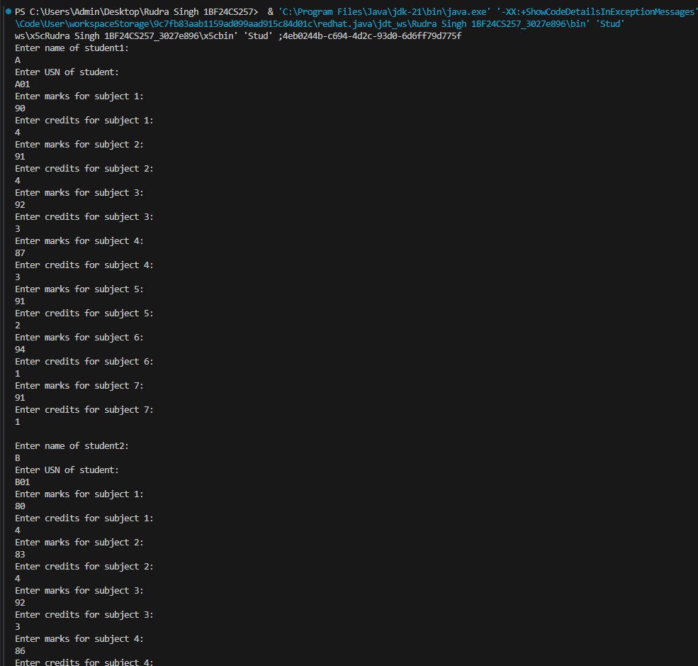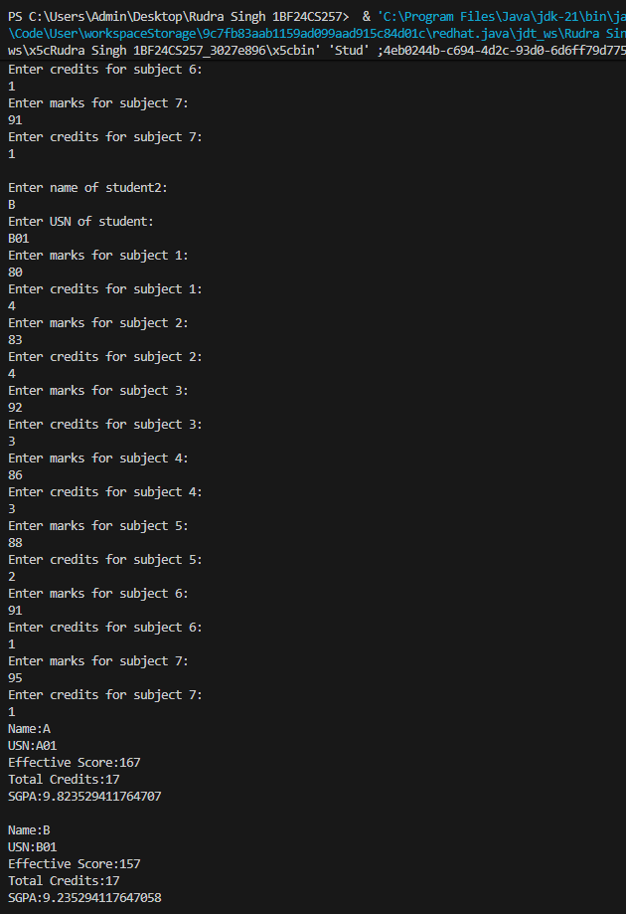

Program 3
Using the toString() method
Code:
import java.util.Scanner;
class Book{
String name;
String author;
int price;
int numpages;
Book(String name,String author,int price,int numpages){
this.name=name;
this.author=author;
this.price=price;
this.numpages=numpages;
}
public String toString(){
String name;
String author;
String price;
String numpages;
name="Book name:"+this.name+"\n";
author="Author:"+this.author+"\n";
price="Price:"+this.price+"\n";
numpages="Number of pages:"+this.numpages+"\n";
return name+author+price+numpages;
}
}
class Book_show{
public static void main(String args[]){
int n;
int i;
int k;
String name;
String author;
int price;
int numpages;
Scanner scnr=new Scanner(System.in);
System.out.println("Enter number of books:");
n=scnr.nextInt();
scnr.nextLine();
System.out.println("Enter data:");
Book bks[]=new Book[n];
for(i=0;i<n;i++){
k=i+1;
System.out.println("");
System.out.println("Enter name of book"+k+":");
name=scnr.nextLine();
System.out.println("Enter name of author:");
author=scnr.nextLine();
System.out.println("Enter price of book:");
price=scnr.nextInt();
System.out.println("Enter number of pages:");
numpages=scnr.nextInt();
scnr.nextLine();
bks[i]=new Book(name,author,price,numpages);
}
for(i=0;i<n;i++){
k=i+1;
System.out.println("");
System.out.println("Entry for book"+k+":");
System.out.println(bks[i]);
}
}
}

Output:
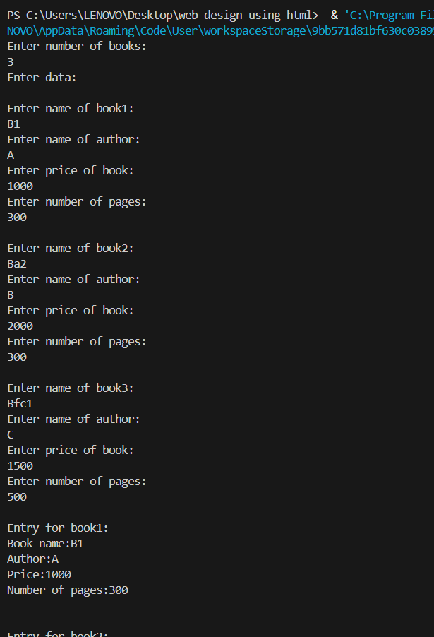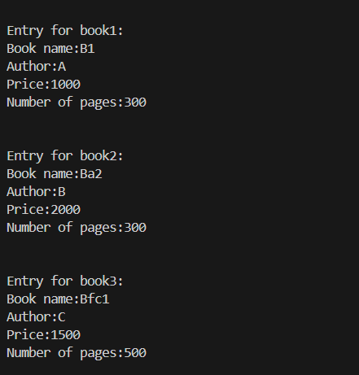

Program 4
Using Abstract Classes
Code:
import java.util.Scanner;
class InputScanner{
int l,b;
}
abstract class Shape extends InputScanner{
abstract void printArea();
}

class Rectangle extends Shape{
void printArea(){
Scanner scnr=new Scanner(System.in);
System.out.print("Enter length of rectangle:");
l=scnr.nextInt();
System.out.print("Enter width of rectangle:");
b=scnr.nextInt();
scnr.nextLine();
double a=l*b;
System.out.println("Area of rectangle:"+a);
System.out.println("");
}
}

class Triangle extends Shape{
void printArea(){
Scanner scnr=new Scanner(System.in);
System.out.print("Enter height of triangle:");
l=scnr.nextInt();
System.out.print("Enter base of triangle:");
b=scnr.nextInt();
scnr.nextLine();
double a=0.5*l*b;
System.out.println("Area of triangle:"+a);
System.out.println("");
}
}

class Circle extends Shape{
void printArea(){
Scanner scnr=new Scanner(System.in);
System.out.print("Enter radius of circle:");
l=scnr.nextInt();
scnr.nextLine();
double a=Math.PI*l*l;
System.out.println("Area of circle:"+a);
System.out.println("");
}
}

class abs{
public static void main(String[] args){
Rectangle r=new Rectangle();
Triangle t=new Triangle();
Circle c=new Circle();
Shape s;
s=r;
s.printArea();
s=t;
s.printArea();
s=c;
s.printArea();
}
}

Output:
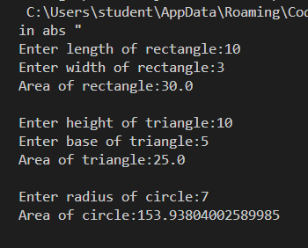

Program 5
Implementing Inheritance
Code:
import java.util.Scanner;
abstract class Account{
Scanner scnr=new Scanner(System.in);
String customer_name;
int acc_no;
String acc_type;
int years;
double balance=0;
void customer(String name,int num,int type){
customer_name=name;
acc_no=num;
if(type==1){
acc_type="Savings Account";
System.out.print("Enter number of years of deposit:");
years=scnr.nextInt();
scnr.nextLine();
}
else{
acc_type="Current Account";
}
}
abstract void display();
abstract void withdraw(double wdr);
abstract void deposit(double dep);
}

class Cur_acc extends Account{
void min_bal(){
if (balance<200) {
System.out.println("Penalty imposed due to low balance.");
balance-=50;
}
}
void deposit(double dep){
balance+=dep;
}
void display(){
System.out.println("Balance:"+balance);
}
void withdraw(double wdr){
if((balance-wdr)>0){
System.out.println("Money withdrawn successfully.");
balance=balance-wdr;
min_bal();
System.out.println("Available balance:"+balance);
}
else{
System.out.println("Insufficient balance.");
System.out.println("Available balance:"+balance);
}
}
}

class Sav_acc extends Account{
void deposit(double dep){
balance_tot+=dep+(balance_tot*Math.pow((1+0.3),(years)))-balance_tot;
}
double r=0.3;
double ci=(balance*Math.pow((1+0.3),(years)))-balance;
double balance_tot=balance+ci;
void min_bal(){
if (balance_tot<200){
System.out.println("Penalty imposed due to low balance.");
balance_tot-=50;
}
}
void display(){
System.out.println("Interest:"+((balance_tot*Math.pow((1+0.3),(years)))-balance_tot));
System.out.println("Balance:"+balance_tot);
}
void withdraw(double wdr){
if((balance_tot-wdr)>0){
System.out.println("Money withdrawn successfully.");
balance_tot=balance_tot-wdr;
min_bal();
System.out.println("Available balance:"+balance_tot);
}
else{
System.out.println("Insufficient balance.");
System.out.println("Available balance:"+balance_tot);
}
}
}

class Banker{
public static void main(String args[]){
String name;
double dep,wdr;
int num,type,choice=1,act;
Scanner scnr=new Scanner(System.in);
Account a;
System.out.print("Enter customer name:");
name=scnr.nextLine();
System.out.print("Enter account number:");
num=scnr.nextInt();
scnr.nextLine();
System.out.print("Enter type of account(1 for savings, 0 for current):");
type=scnr.nextInt();
scnr.nextLine();
if(type==1){
a=new Sav_acc();
}
else{
a=new Cur_acc();
}
a.customer(name,num,type);
while(choice==1){
System.out.println("1)Display balance");
System.out.println("2)Deposit money");
System.out.println("3)Withdraw money");
System.out.println("What would you like to do?(1,2,3)");
act=scnr.nextInt();
scnr.nextLine();
switch(act){
case 1:
a.display();
break;
case 2:
System.out.println("Enter amount to deposit:");
dep=scnr.nextDouble();
scnr.nextLine();
a.deposit(dep);
break;
case 3:
System.out.println("Enter amount to withdraw:");
wdr=scnr.nextDouble();
scnr.nextLine();
a.withdraw(wdr);
break;
default:
System.out.println("Invalid input.");
break;
}
System.out.print("Would you like to perform any other actions?(1 for yes,0 for no)");
choice=scnr.nextInt();
scnr.nextLine();
}

}
}

Output:
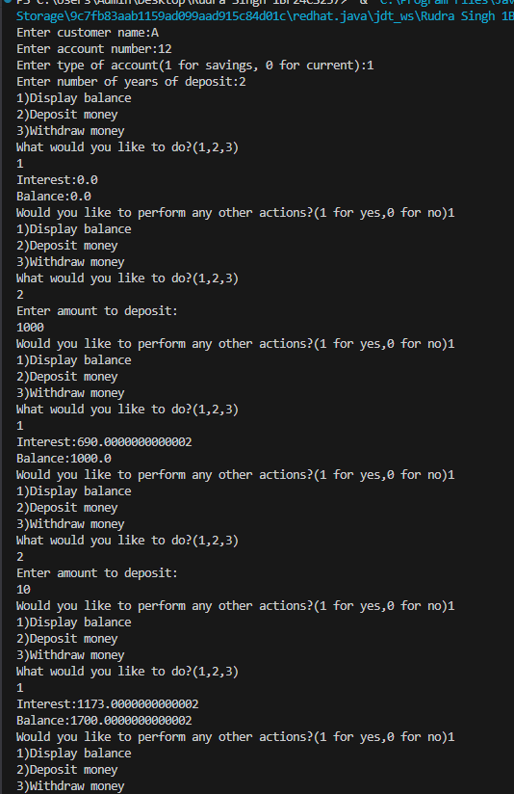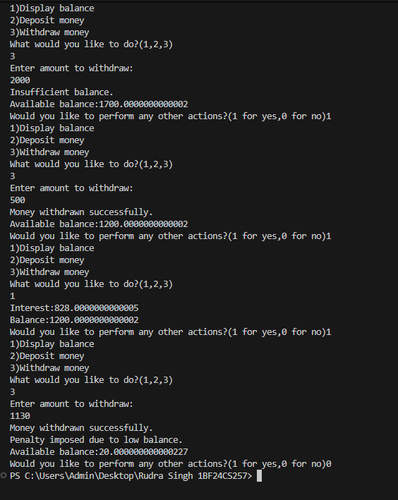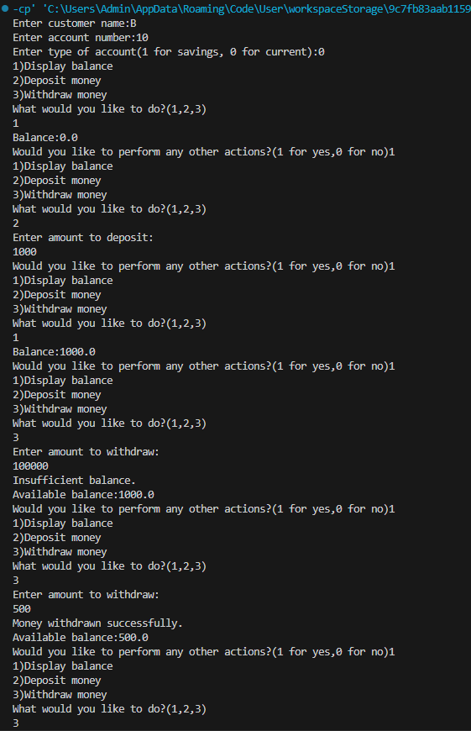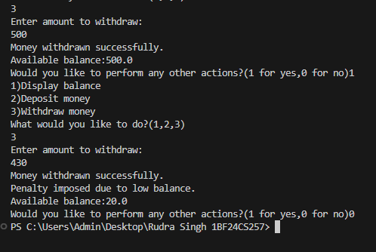

Program 6
Using Packages
Code:
CIE Package : Class Internals:

package CIE;
import java.util.Scanner;
public class Internals extends Student{
public int marksin[] = new int[5];
public void CIEmarks(){
Scanner scnr=new Scanner(System.in);
int i;
System.out.println("Enter CIE marks:");
for(i=0;i<5;i++){
System.out.print("Enter marks for subject "+(i+1)+":");
marksin[i]=scnr.nextInt();
scnr.nextLine();
}
}
}

CIE Package : Class Student:

package CIE;
import java.util.Scanner;

public class Student {
public String usn = new String();
public String name = new String();
public int sem;
Scanner scnr=new Scanner(System.in);
public void inputDetails(){
System.out.print("Enter USN:");
usn=scnr.nextLine();
System.out.print("Enter Name:");
name=scnr.nextLine();
System.out.print("Enter Sem:");
sem=scnr.nextInt();
scnr.nextLine();
}
public void Details(){
System.out.println("Name:"+name);
System.out.println("Usn:"+usn);
System.out.println("Sem:"+sem);
}
}

SEE Package : Class External:

package SEE;
import CIE.Internals;
import java.util.Scanner;
public class External extends Internals{
int i=0;
public int marks[]=new int[5];
public int finalMarks[]=new int[5];
public void SEEmarks(){
Scanner scnr=new Scanner(System.in);
System.out.println("Enter SEE marks:");
for(i=0;i<5;i++){
System.out.print("Enter marks for subject "+(i+1)+":");
marks[i]=scnr.nextInt()/2;
scnr.nextLine();
}
}
public void Final_marks(External in){
System.out.println("Final marks:");
for(i=0;i<5;i++){
finalMarks[i]=marks[i]+in.marksin[i];
}
for(i=0;i<5;i++){
System.out.println("Marks for subject"+(i+1)+":"+finalMarks[i]);
}
}
}

Main:

import SEE.External;

class Main{
public static void main(String args[]){
External e=new External();
e.inputDetails();
e.CIEmarks();
e.SEEmarks();
e.Details();
e.Final_marks(e);
}
}

Output:
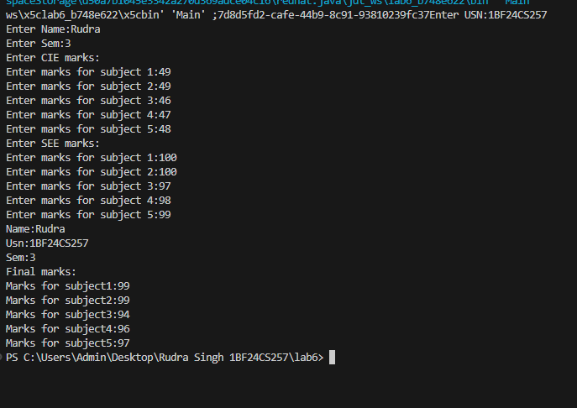

Program 7
Implementing User Defined Exceptions
Code:
import java.util.Scanner;

class WrongAge extends Exception{
public WrongAge(int i){
if(i==1){
System.out.println("Age cannot be negative or zero.");
}
else if(i==2){
System.out.println("Father's age cannot be less than son's age.");
}
}
}

class Father{
int f_age;
Scanner scnr=new Scanner(System.in);
Father() throws WrongAge{
System.out.print("Enter father's age:");
f_age=scnr.nextInt();
scnr.nextLine();

if(f_age<=0){
throw new WrongAge(1);
}
}
void display(){
System.out.println("Father's age:"+f_age);
}
}

class Son extends Father{
int s_age;
Son() throws WrongAge{
System.out.print("Enter son's age:");
s_age=scnr.nextInt();
scnr.nextLine();

if(s_age<=0){
throw new WrongAge(1);
}
else if(s_age>=f_age){
throw new WrongAge(2);
}
}
void display(){
System.out.println("Son's age:"+s_age);
super.display();
}
}

public class age_taker {
public static void main(String[] args) {
try{
Son s=new Son();
System.out.println("Valid ages.");
s.display();
}
catch(WrongAge w){
System.out.println("Therefore, wrong age.");
}
}
}

Output:
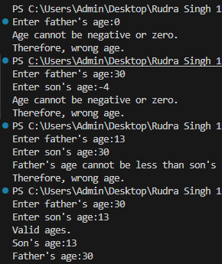

Program 8
Multi-Threading
Code:
class Typer extends Thread{
public void run(){
while (true){
System.out.println("BMS College of Engineering");
try {
Thread.sleep(10000);
}
catch (InterruptedException e){
System.out.println("Interrupted");
}
}
}
}
class Typer2 extends Thread{
public void run(){
while (true){
System.out.println("CSE");
try {
Thread.sleep(2000);
}
catch (InterruptedException e){
System.out.println("Interrupted");
}
}
}
}

public class BMS_CS{
public static void main(String args[]) {
Typer t1=new Typer();
Typer2 t2=new Typer2();
t1.start();
t2.start();
}

}

Output:
